**Task Manager Instructions**

Thank you for choosing the Task Manager system. This system is designed to help service representatives manage service requests. While learning to use the application, you will find the option menus can be accessed by tapping the vertical 3 dot icon in the upper right-hand corner.

**Login**

When the application is first started the Login menu will appear as show in figure 1. Enter the username user1 and default password 1234. The user1 profile is the team manager. The alternate id's (user2 and user3 with the default password 1234) are employee profiles.

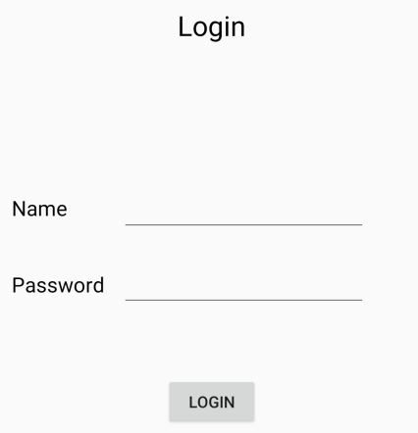

Figure

If logging in for the first time the next screen will be the Change Password screen as shown in figure 2. You will be prompted to change the password. The new password must contain 8 characters: a number, an uppercase letter and a lowercase letter. The ‘Submit’ button is in the upper right corner in the options menu. After changing the password, the Task List screen is shown.

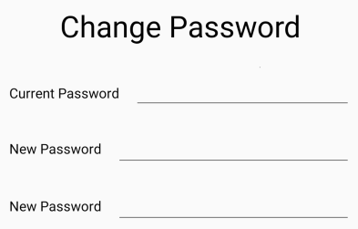

Figure

The Change Password screen can be accessed at any time from the Task List options menu.

**Adding a Task**

The Task List screen will be shown first. On this screen the headers 'Customer', 'Created', 'Problem', and ‘Status’ will be visible with no data. Since there are no tasks to dispatch to initially, select the options menu and then 'Add Task'. There are some customers already in the database that can be used to create a task, or a new customer can be created. Select a customer, then enter the customers problem in the Problem Description area as shown on figure 3 and select 'Submit' from the options menu. When a task is submitted, the Task List screen is now shown with the new task. The Task List may be better displayed if the device is held horizontally as shown in figure 4.Tap the task to go to the Task Details screen.

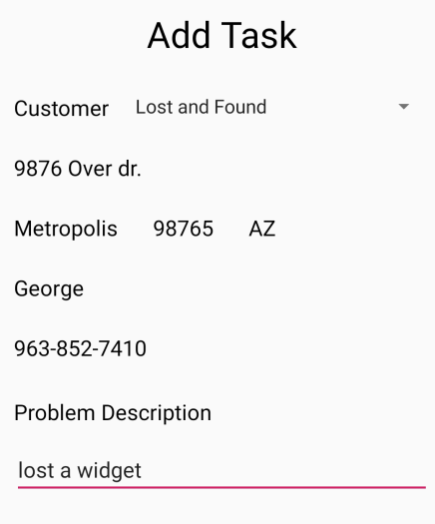 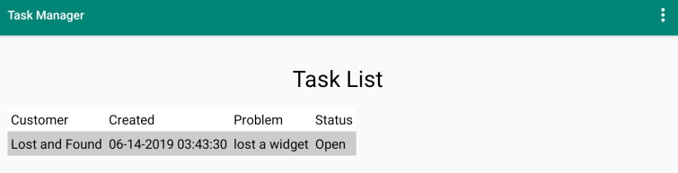

Figure Figure 4

**Dispatching to a Task**

First fill in the Start Odometer and then select 'Enroute' from the options menu. Next, on arrival to the customer site, fill in the End Odometer and select 'Arrived' from the options menu. If any parts are used for the task, select 'Assign Parts to Task' from the options menu. If any parts are needed for the task that the employee doesn't have, they may be ordered from the 'Order Parts' option. When the task is complete enter any task notes and select 'Complete' from the options menu and the Task List screen will be displayed. The 'Incomplete Time' and ' Incomplete Assist' options are available if the task is not done and the employee needs to leave the customer site or recruit assistance.

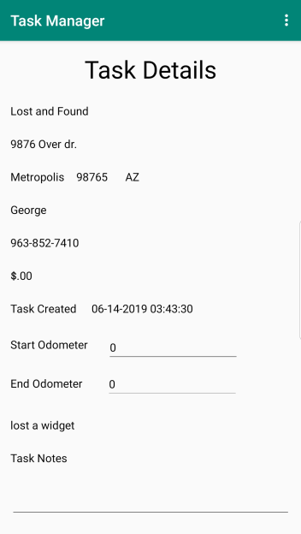 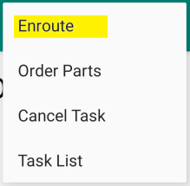 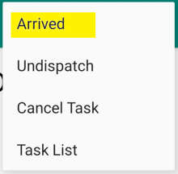 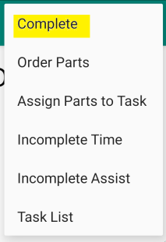

Figure Figure Figure Figure

**Assigning parts to a Task**

While at a task, any parts that are used in a repair may be assigned to the task. Select 'Assign Parts to Task' from the options menu. A part is assigned to the task by tapping on the desired part. Multiple taps increment the quantity assigned to the call. Tapping on an assigned part will transfer the part back to the on-hand inventory. The Search function shows on-hand inventory that matches the entered search parameters. The total display at the bottom of the screen keeps track of how much the customer will get billed. When done assigning parts to the task, select submit from the options menu to return to the Task Details screen.

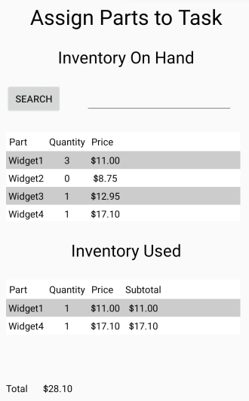

Figure

**Ordering Parts for a Task**

Parts can be ordered for a Task at any time regardless of dispatch status. This is so a service rep can troubleshoot over the phone and pre-order any parts they may not have on hand. The Order Parts screen functions the same as the Assign Parts to Task screen. On the submission of an order, the task status will be changed to Parts on order and the service rep may dispatch to a new task.

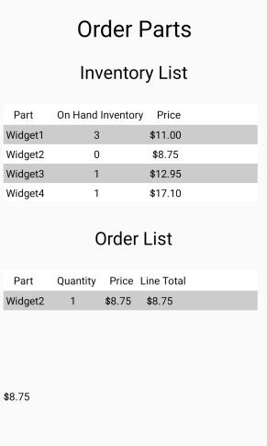

Figure

**Inventory Management**

Select 'Inventory List' from the Options menu. The Inventory List displays the employees On Hand inventory and the Transfer List. Occasionally one employee has a part that another needs. A part may be transferred by adding it to the Transfer List, selecting the recipient, and submitting the transfer.

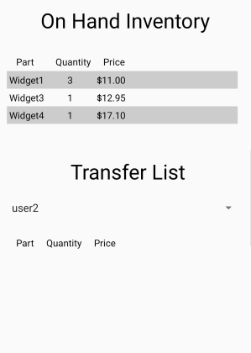

Figure

**Receiving Parts Orders**

Parts orders may be received in the Receive Orders screen. From the Inventory List screen options menu, select 'Receive Orders', and a list of outstanding orders is shown in the Orders area. When an order is selected the order turns yellow and a parts list is shown for that order. Selecting 'Accept Order' from the options menu adds the parts in the selected order to the employees inventory.

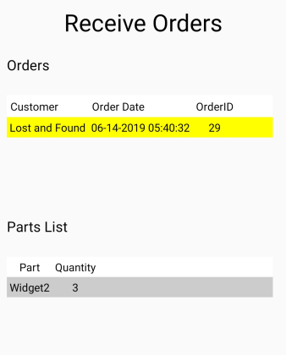

Figure

**Team Management**

From the Task List options menu. The team management screen displays a list of employees. Managers will also see a status column for each employee and an additional item in the options menu to 'Add/Edit Employee'. In the Add/Edit Employee screen the manager can use the drop-down menu to add a new employee or change the status and contact information for existing employees.

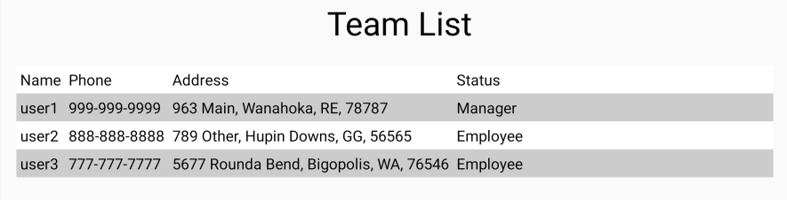

Figure

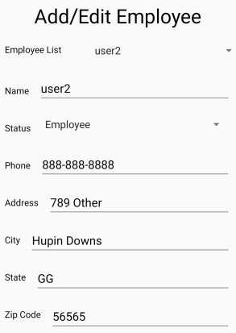

Figure

**Detailed Screen Descriptions**

**Task List**

The Task List screen displays a list of available tasks for the employee to perform. Selecting an available task will display the Task Details menu. Selecting the options menu will display:

* Add Task: New tasks can be added to the task list.
* Add Customer: New customers can be added to the customer list.
* Inventory List: Inventory functions can be performed in this menu.
* Team Management: Team management functions can be performed in this menu.
* Reports: Reports can be displayed in this menu.
* Change Password: The password for the currently logged in profile can be changed here.
* Log Out: User is logged out of the system and taken to the login screen.

**Add Task**

The Add Task screen allows for the creation of a new task. When a customer is selected from the dropdown menu, the rest of the customer fields are automatically populated with that customers information. The problem can be entered in the Problem Description field. Selecting the options menu will display:

* Add Customer: New customers can be added to the customer list.
* Edit Customer: The customer information currently displayed can be edited.
* Task List: Returns to the Task List Screen.
* Submit: Adds the new task to the task list.

**Task Details**

The Task Details screen displays the customer and task information. Selecting the options menu will give the options of:

* Enroute: Sets the employee as enroute to the task. The start odometer entry is required.
* Start: Displayed if the task is set to Enroute. Sets the task as started. The end odometer entry is required.
* End: Displayed if the task is set to Start. Sets the task as ended.
* Assign Inventory to Task: Goes to the Assign Inventory screen.
* Order Parts: Goes to the Parts Order screen.
* Cancel Task: Cancels the currently displayed task.
* Task List: Return to the Task List screen.

Note: At the completion of a task it is recommended that a note is added to the task detailing any work done or relevant information for that task.

**Add Customer**

The Add Customer screen allows for the creation of a new customer. All fields must be filled before submission or the unfilled fields will turn red and the submission will fail. Selecting the options menu will give the options of:

* Task List: Return to the Task List screen.
* Submit: Adds the new customer to the customer list.

**Edit Customer**

The Edit Customer screen allows for the modification of an existing customer. Selecting a field will allow the editing of that field. Selecting ‘Submit' from the options menu will update the customer information and return the user to the Add Task screen.

**Order Parts**

The Order Parts screen allows an employee to order parts that they may not currently have in their inventory for a task A part may be added to the Order List by tapping the part in the Inventory List. Each additional tap on that part increments the order quantity by 1. A tap on an item in the Order list decrements the quantity by 1 or removes it if the quantity becomes zero. An order total is displayed on the bottom so that an estimate may be given to the customer. The options menu allows for submitting the order or canceling the order. Either will return the user to the Task Details screen.

**Inventory List**

The Inventory List screen displays on-hand inventory for the employee. A part may be added to the Transfer List by tapping the part in the inventory list. Each additional tap on that part increments the order quantity by 1. A tap on an item in the Transfer List decrements the quantity by 1 or removes it if the quantity becomes zero. After building a list, selecting Submit Transfer in the options menu will complete the transfer to the selected employee. Selecting the options menu will display the options of:

* Task List: Return to the Task List screen.
* Receive Orders: Goes to the Receive Orders screen.
* Submit Transfer.

**Team Management**

The Team Management Screen displays a list of employees. The manager profile can see the employee status column and the 'Add/Edit Employee' menu option. The 'Task List' menu option returns the user to the Task List screen.

**Receive Orders**

A list of open orders is displayed in the Order List and when an order is selected, a list of parts for that order is displayed in the Parts List. The selected order may then be received into the employee’s inventory by selecting the 'Submit' option from the options menu. When done receiving open orders, selecting the 'Inventory List' option will return the user to the Inventory List screen.

**Assign Parts to Task**

The Assign Parts to Task screen displays the employee's On-Hand Inventory in the upper area of the screen and the Inventory Used in the lower area. A total cost of inventory used is displayed at the bottom of the screen. A part may be assigned to a task by tapping on the desired part. The On-Hand inventory will be decremented by one and the part will be added to the Inventory Used. Selecting Submit in the options menu will complete the process and return the user to the Task Details screen.

**Add/Edit Employee**

The Add/Edit Employee screen is only available to the managers. The top dropdown menu gives the option of adding a new employee or editing an existing employee. The 'Status' drop down menu allows the employee status to be set to Employee, Manager, or Terminated. Selecting the options menu will display the options of:

* Task List: Return to the Task List Screen.
* Team List: Return to the Team List Screen.
* Submit: Adds/Updates the employee information in the database. All fields are required.

**Reports**

The Reports screen can display two reports, the Mileage Report and the Task Report. These reports are selected in the options menu. The Mileage Report displays the date and the number of miles traveled for each task. The Task Report shows the date, amount of time it took to travel to the task, and the amount of time spent on the task. These reports can be filtered using the Period dropdown menu, which has the options for 1 Month, 3 Month, and 1 Year.